# Version History

| **Version** | **Date** | **Additions / Modifications** | **Prepared / Revised By** |
| --- | --- | --- | --- |
| 1.0 | 25-08-2023 | Initial version | Shiena Clare Parac |
|  |  |  |  |
|  |  |  |  |

## Interface / API Design

## https://dev.azure.com/dd-managed-services/PE%20-%20Mule%20Enablement%20APAC/_git/shienaclare-parac-api-weather-v1?path=/src/main/resources/api/api-weather-v1.raml

## Operation description

POST /users – Create users

## Sequence Diagram

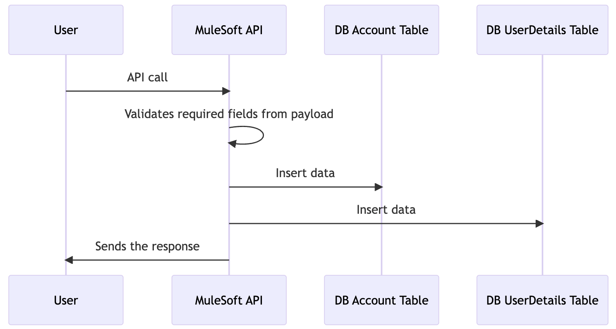

## Data Mapping and Transformation Rules (API - end point)

### POST /users **Request - Header**

| **Param** | **Param Type** | **Value** |
| --- | --- | --- |
| requestCode | Header | aOEF3M2cEG0204NO |

### POST /users **Request payload**

|  |
| --- |
| {  "users": [{  "username": "john123",  "fullname": "John White Smith",  "birthday": "02-05-1990",  "gender": "male",  "dateRegistered": "20-08-2012"  },  {  "username": "jackpeters",  "fullname": "Jack Peters",  "birthday": "11-06-1985",  "gender": "male",  "dateRegistered": "25-09-2014"  },  {  "username": "jenniesummers",  "fullname": "Jennie Summers",  "birthday": "12-11-1979",  "gender": "female",  "dateRegistered": "20-08-2013"  }  ]  } |

### POST /users **Response payload**

#### POST /users **Response (Success)**

|  |
| --- |
| {  "message": "Success",  "responseCode": "201"  } |

#### POST /users **Response (Error)**

|  |
| --- |
| {  "error": {  "status": "400",  "code": "BAD_REQUEST",  "title": "The request is invalid",  "details": "The input contains invalid data: /users/0 required key [username] not found"  }  } |

### Response Status Code and Headers

| **Key** | **Value** |
| --- | --- |
| Success | 200 |
| BAD_REQUEST | 400 |
| NOT_FOUND | 404 |
| METHOD_NOT_ALLOWED | 405 |
| NOT_ACCEPTABLE | 406 |
| MEDIA_TYPE_UNSUPPORTED | 415 |
| SERVER_ERROR | 500 |
| NOT_IMPLEMENTED | 501 |
| TIMEOUT | 504 |
| UNAUTHORIZED | 401 |

Source to Target Message Mapping (Request / Response)

| **Source Service Name** | **Source Field Name** | **DataType** | **Sample** | **Target Database Table** | **Target Table Field Name** | **Sample** | **Optional** | **Transformation Rules / Business Rules** | **Notes** |
| --- | --- | --- | --- | --- | --- | --- | --- | --- | --- |
| POST /users |  |  |  | Account |  |  |  |  |  |
|  | username | String | john123 |  | username |  | **N** | Pass-through |  |
|  |  |  |  |  | active | 1 | **N** | Set to 1 |  |
|  | dateRegistered | String | 20-08-2012 |  | date_registered |  | **N** | Pass-through |  |
|  |  |  |  | UserDetails |  |  |  |  |  |
|  | fullname | String | John White Smith |  | fullname |  | **N** | Pass-through |  |
|  | birthday | String | 02-05-1990 |  | birthday |  | **N** | Pass-through |  |
|  | gender | String | male |  | gender |  | **N** | If “female”, set to “F”. If “male”, set to “M” |  |

## Operation description

GET /users – Get all users

## Sequence Diagram

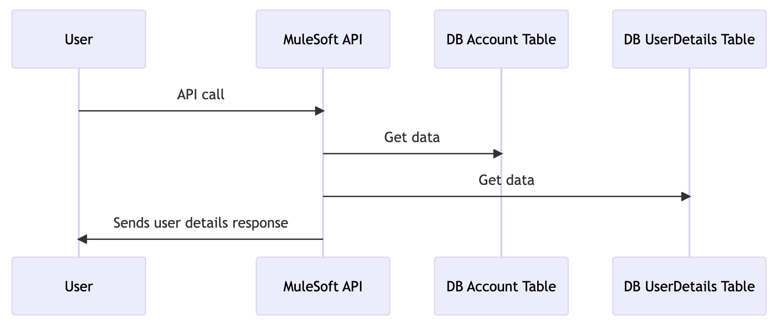

## Data Mapping and Transformation Rules (API - end point)

### **GET /users Request - Header**

| **Param** | **Param Type** | **Value** |
| --- | --- | --- |
| requestCode | Header | aOEF3M2cEG0204NO |

### **GET /users** **Response payload**

#### **GET /users** **Response (Success)**

|  |
| --- |
| {  "users": [  {  "username": "john123",  "fullname": "John White Smith",  "age": 33,  "gender": "Male",  "dateRegistered": "20-08-2012"  },  {  "username": "jackpeters",  "fullname": "Jack Peters",  "age": 38,  "gender": "Male",  "dateRegistered": "25-09-2014"  },  {  "username": "jenniesummers",  "fullname": "Jennie Summers",  "age": 43,  "gender": "Female",  "dateRegistered": "20-08-2013"  }  ]  } |

#### **GET /users Response (Error)**

|  |
| --- |
| {  "error": {  "status": "401",  "code": "UNAUTHORIZED",  "title": "Unauthorized",  "details": "This endpoint requires all requests to be authenticated"  }  } |

### Response Status Code and Headers

| **Key** | **Value** |
| --- | --- |
| Success | 200 |
| BAD_REQUEST | 400 |
| NOT_FOUND | 404 |
| METHOD_NOT_ALLOWED | 405 |
| NOT_ACCEPTABLE | 406 |
| MEDIA_TYPE_UNSUPPORTED | 415 |
| SERVER_ERROR | 500 |
| NOT_IMPLEMENTED | 501 |
| TIMEOUT | 504 |
| UNAUTHORIZED | 401 |

Source to Target Message Mapping (Request / Response)

| **Source Table** | **Source Field Name** | **DataType** | **Sample** | **Target Service** | **Target Service Field Name** | **Sample** | **Optional** | **Transformation Rules / Business Rules** | **Notes** |
| --- | --- | --- | --- | --- | --- | --- | --- | --- | --- |
| Account |  |  |  | GET /users |  |  |  |  |  |
|  | username | String | john123 |  | username | john123 |  | Pass-through |  |
|  | date_registered | String | 20-08-2012 |  | dateRegistered | 20-08-2012 |  | Pass-through |  |
| UserDetails |  |  |  | GET /users |  |  |  |  |  |
|  | fullname | String | John White Smith |  | fullname | John White Smith |  | Pass-through |  |
|  | birthday | String | 02-05-1990 |  | age | 33 |  | Calculate age based on birthday |  |
|  | gender | String | M |  | gender | Male |  | If “F”, set to “Female”. If “M”, set to “Male” |  |

## Operation description

GET /users/{username} – Get user by username

## Sequence Diagram

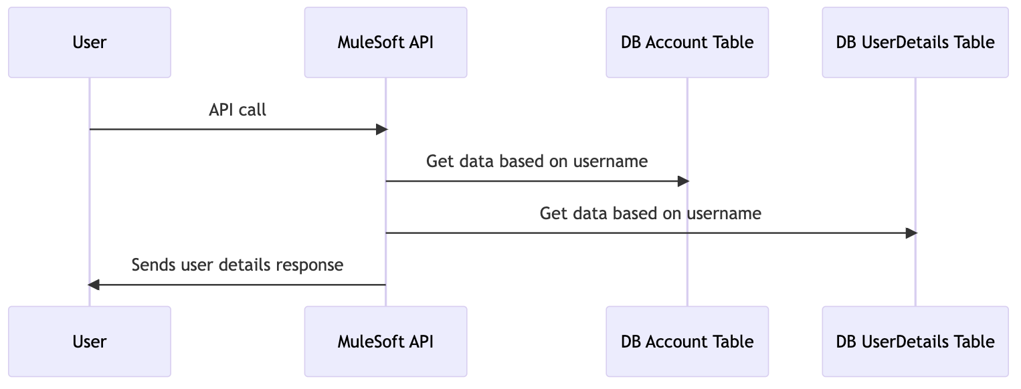

## Data Mapping and Transformation Rules (API - end point)

### **GET /users**/{username}**Request - Header**

| **Param** | **Param Type** | **Value** |
| --- | --- | --- |
| requestCode | Header | aOEF3M2cEG0204NO |

### **GET /users**/{username} **Response payload**

#### **GET /users**/{username} **Response (Success)**

|  |
| --- |
| {  "users": [  {  "username": "john123",  "fullname": "John White Smith",  "age": 33,  "gender": "Male",  "dateRegistered": "20-08-2012"  }  ]  } |

#### **GET /users**/{username}  **Response (Error)**

|  |
| --- |
| {  "error": {  "status": "404",  "code": "NOT_FOUND",  "title": "User not found",  "details": "User not found: User with the given username does not exist"  }  } |

### Response Status Code and Headers

| **Key** | **Value** |
| --- | --- |
| Success | 200 |
| BAD_REQUEST | 400 |
| NOT_FOUND | 404 |
| METHOD_NOT_ALLOWED | 405 |
| NOT_ACCEPTABLE | 406 |
| MEDIA_TYPE_UNSUPPORTED | 415 |
| SERVER_ERROR | 500 |
| NOT_IMPLEMENTED | 501 |
| TIMEOUT | 504 |
| UNAUTHORIZED | 401 |

Source to Target Message Mapping (Request / Response)

| **Source Table** | **Source Field Name** | **DataType** | **Sample** | **Target Service** | **Target Service Field Name** | **Sample** | **Optional** | **Transformation Rules / Business Rules** | **Notes** |
| --- | --- | --- | --- | --- | --- | --- | --- | --- | --- |
| Account |  |  |  | GET /users |  |  |  |  |  |
|  | username | String | john123 |  | username | john123 |  | Pass-through |  |
|  | date_registered | String | 20-08-2012 |  | dateRegistered | 20-08-2012 |  | Pass-through |  |
| UserDetails |  |  |  | GET /users |  |  |  |  |  |
|  | fullname | String | John White Smith |  | fullname | John White Smith |  | Pass-through |  |
|  | birthday | String | 02-05-1990 |  | age | 33 |  | Calculate age based on birthday |  |
|  | gender | String | M |  | gender | Male |  | If “F”, set to “Female”. If “M”, set to “Male” |  |